Westward Expansion
1801-1861
- Big Ideas
  - Between ____________ and _____________, exploration was encouraged as America underwent vast _________________________________________ and settlement.
  - Westward migration was influenced by ______________________________ and _______________________________.
  - Prior to the Civil War, most __________________________ in America was in the ________________; however, the equipment produced in the North had an impact on the __________________________________________ in the south.
  - The ____________________________________ worked to end slavery.
  - The __________________________________________ movement helped women gain equal rights.

- Post Revolutionary America
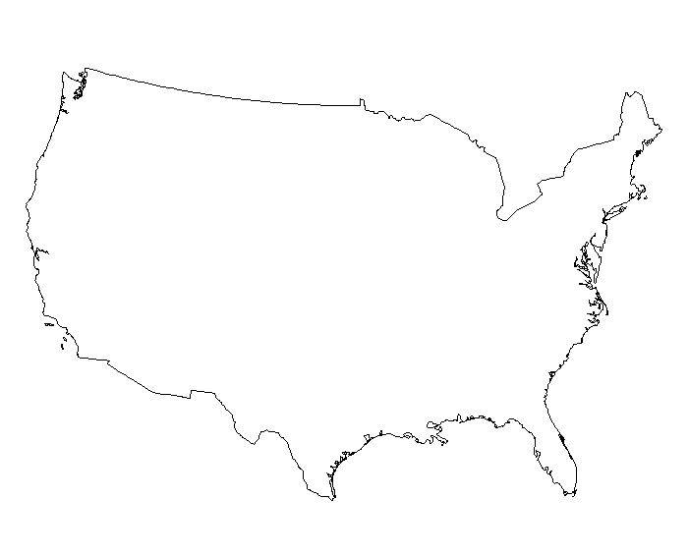
- The Louisiana Purchase
  - ________________________________ bought land from France (The Louisiana Purchase), which doubled the size of the United States.
  - In the ____________________________________________________, Meriwether Lewis and William Clark explored the Louisiana Purchase from the _____________________________________ to the ____________________________.

- Other Territories
  - Florida
    - _______________________________________ gave Florida to the United States through a treaty.
  - Texas
    - Texas was added after it became an _____________________________________________.
  - Oregon
    - The Oregon Territory was divided by the _________________________________________________________________.
  - California
    - War with __________________________________________ resulted in California and the southwest territory becoming part of the United States.

Florida, Texas, Oregon, California
- Factors Affecting Westward Expansion
  - Geographic and economic factors that influenced westward movement

- Important Inventions
  - The _______________________________ was invented by ___________________________________ . It increased the production of cotton and thus _________________________________ the need for slave labor to cultivate and pick the cotton.
  - __________________________________________________________ worked to invent the reaper. The reaper increased the productivity of the American farmer
  - The __________________________ was improved by ______________________________________ . It eventually provided faster river transportation that connected Southern plantations and farms to Northern industries and Western territories.
  - The _________________________________ provided faster land transportation.

- Abolitionists
  - Harriet Tubman
    - Supported the secret route, or ______________________________, that helped escaped southern slaves to reach northern free states.
  - Frederick Douglass
    - _____________________________________________________
    - Escaped slavery and became an abolitionist.
  - William Lloyd Garrison

- Beliefs of Civil Rights
  - Suffrage movement
    - Supporters declared that “___________________________________________________________.”
    - Supporters believed that women were deprived of _________________________________.

  - The movement was led by _________________________________ who began their campaign before the Civil War and continued after the war had ended.

- Female Leaders
  - Isabel Sojourner Truth

    - Was born a slave and worked for equal rights for women as well as for the end of slavery
  - Susan B Anthony
    - Supporter of the ___________________________________________
    - Declared that women and men are entitled to the same rights in all areas of life, including the right to vote and own property
  - Elizabeth Cady Stanton
    - Leader of the Suffrage Movement
    - Worked closely with ____________________________________________
    - Wrote The _________________________________________________

