Name_______________________________________ Period______ Pg___
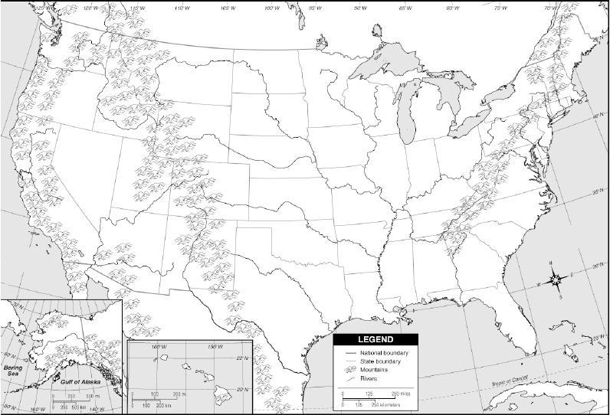

When traveling from the East Coast to the West Coast of the United States, What Physical barriers will you encounter? Write your answer below

