Major Concepts to Understand
- Native American Migration patterns (how did they get here?)
- Impact of European Exploration on Native Americans
- European motivation for exploration
- Impact of the Columbian Exchange
- Why Explorers wanted to find the Northwest Passage
- Major goals of European Exploration
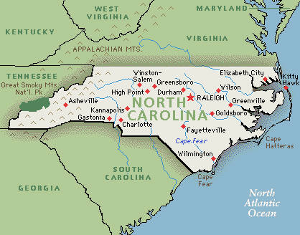
“I gave to them some red caps, and to others glass beads, which they hung about their necks, and many other things of slight value, in which they took much pleasure…They all go quite naked as their mothers bore them. None of them more than 30 years old, very well built, of very handsome bodies and fine faces. They ought to be good servants and of good skill, for I see that they repeat very quickly whatever is said to them” – Christopher Columbus, October 12, 1492

Locate the directions of cities on this map. 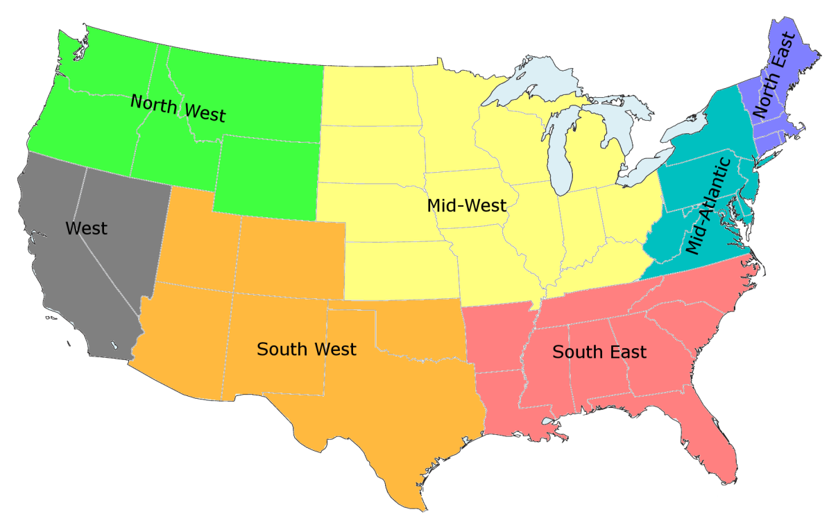Identify major characteristics of each of these regions.
“His majesty having been graciously pleased, by his charter bearing date the 24th of March, in the 15th year of his reign, out of a pious and good intention for the propagation of the Christian faith amongst the barbarous and ignorant Indians, the enlargement of his empire and dominions, and enriching of his subjects, to grant and confirm to us...” - A Declaration and Proposals of the Lord Proprietor of Carolina

“Three days after I captured this city, some of the Indians who lived here came to offer to make peace. They bought me some turquoises and poor mantles, and I received them in His Majesty’s name with as good a speech as I could, making them understand the purpose of my coming to this country, which is, in the name of His Majesty and by the commands of Your Lordship, that they and all others in this province should become Christians and should know the true God for their Lord…” – Coronado’s Report to Viceroy Mendoza- August 3, 1540

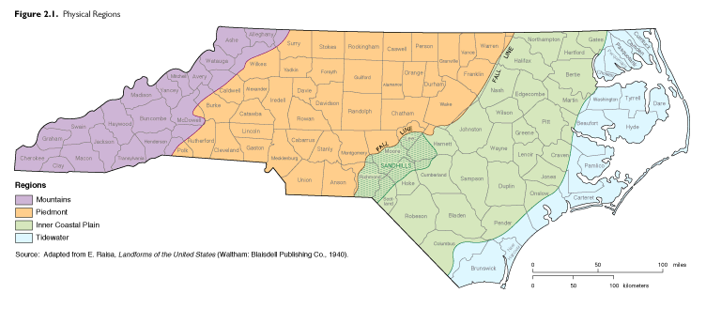
Identify major characteristics of the three major regions of North Carolina.

Have the ability to analyze the following passages.

