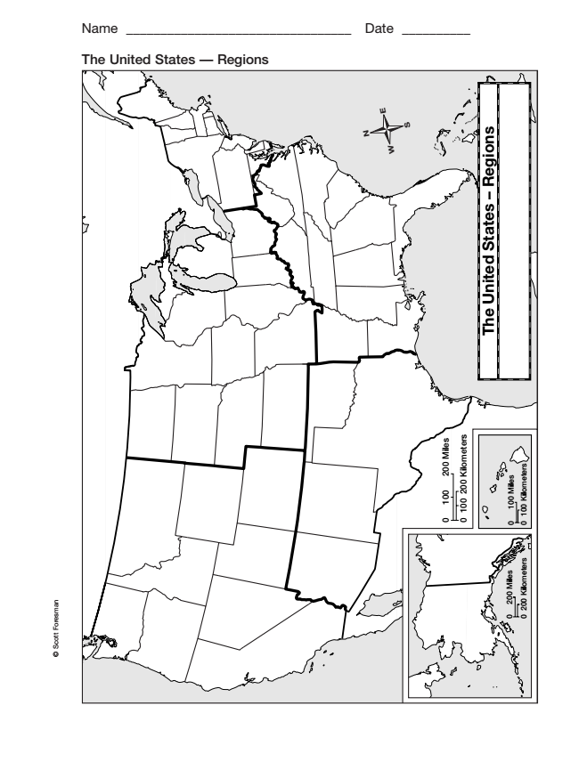
Name _________________________________ Date __________
The United States — Regions
N
E
S
W

