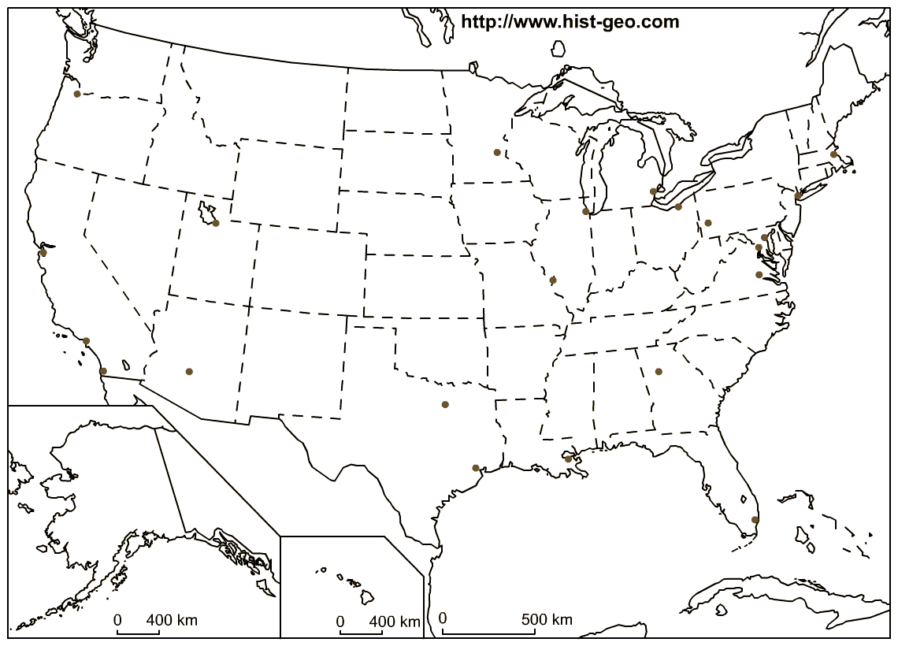Name______________________________________ Period_____ pg ______

Think about the location of the major cities. Why do you think they are found along the coast of United States? Write your answer below

