You should have the ability to answer the following questions:
- What is the system of checks and balances? How does it influence government?
- What document establishes the current plan of government in the United States?
- What was the Great Compromise and how did it influence government?
- Why were the first ten amendments added to the US Constitution?
- Under the Constitution, who has the power?
- Which governing body is most directly influenced by a state’s population?
- What were similarities and differences of Federalists and Anti-Federalists?
- What were the strengths and weaknesses of the Articles of Confederation?
- Why was Shay’s Rebellion important in the foundation of American government?
- What are the major responsibilities for each of the three branches of government?
You should understand the following sources:
Excerpt from: Objections to the Constitution (George Mason, October 1787)
“There is no declaration of rights; and , the laws of the general government being paramount to the laws and constitutions of the several states, the declaration of rights in the separate states are no security. Nor are the people secured even in the enjoyment of the benefit of the common law, which stands here upon no foundation than its having been adopted by the respective acts forming the constitutions of the several states…”
“…This government will commence in a moderate aristocracy: it is at present impossible to forsee whether it will, in its operation, produce a monarchy or a corrupt oppressive aristocracy; it will most probably vibrate some years between the two, and then terminate in the one or the other.”
Comparative Population Counts for Southern States, 1790
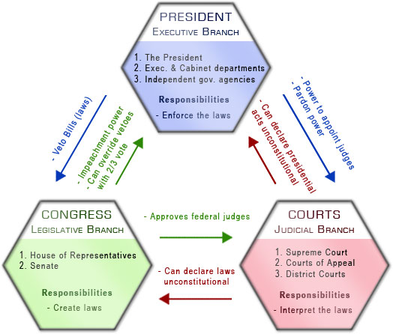

Preamble to the Constitution of the United States
We the People of the United States, in order to form a more perfect Union, establish Justice, insure domestic Tranquility, provide for the common Defense, promote the General Welfare and secure our Blessings of Liberty to Ourselves and our Posterity, do ordain and establish this Constitution for the United States of America.

